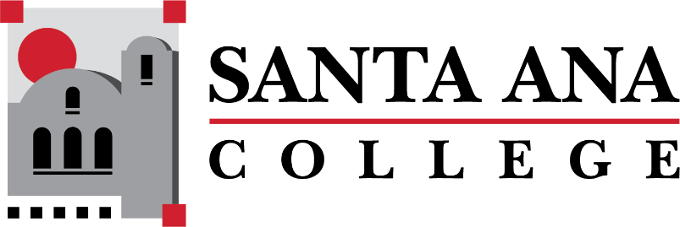

Dual Enrollment Workgroup Agenda
Tuesday, November 15, 2022 2:00-3:00pm., Hybrid
S-215 & Zoom

- Report out - Working Subgroups
  - Timelines
  - Faculty Handbook
  - A&R
  - SAUSD Team
- Canvas Report Out – Distance Education
- Assessment Center – Maria Aguilar Beltran (streamlining waivers for student placement and assessment)
- Bookstore Costs Discussion – Basti Lopez
  - Spring 2023 Updates

Upcoming Meetings: December 6, 2022 | 2:00-3:00pm Hybrid
Save the Dates: DuE Retreats
- January 25, 2023 | 9:00am-12:00pm | JSC 219
- May 12, 2023 | 9:00am-12:00pm | JSC 219

